

FAST FACT DATES

&

INTEGRATION WITH LIBRARY FIELDS

#### Document History

|  |  |  |  |  |  |
| --- | --- | --- | --- | --- | --- |
| Date | Version | Revision Details | Author | Reviewed By | Approved By |
| 15 Sep 2015 | 1.0 | FAST FACT DATES AND INTEGRATION WITH LIBRARY FIELD | Ajith PA | Mahesh KM |  |
|  |  |  |  |  |  |

#### Table of Contents

|  |  |  |
| --- | --- | --- |
| Sl No | Section | Page No |
| 1 | Introduction | 4 |
| 2 | Database Objects Used in Fast Fact Dates: | 5 |
| 3 |  |  |

## INTRODUCTION

Fast Facts dates are used to save different kind of client dates in the system like Background clearance date, Medical clearance date etc. Click on fast facts icon in the client screen then fast fact window will open.

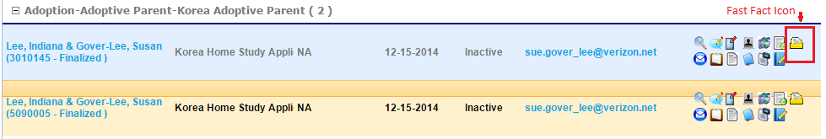

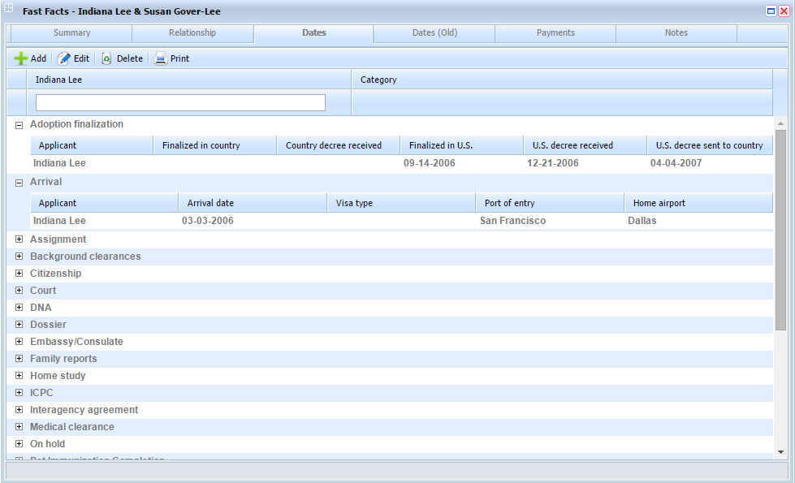

**Database Objects Used in Fast Fact Dates**:

|  |  |  |  |
| --- | --- | --- | --- |
| **Table** | **Column/Parameter** | **Type** | **Type** |
| **FastFactlookupTable** | Id | int | Table |
| LkpName | varchar |
| DisplayField | varchar |
| ValueField | varchar |
| Query | varchar |
| Parameter | varchar |
| **FastFactsConfiguration** | ID | int | Table |
| FieldId | int |
| FieldName | varchar |
| Caption | varchar |
| FieldType | int |
| Seq | int |
| DataField | varchar |
| LookUpId | int |
| **FastFactData** | ID | int | Table |
| User_ID | int |
| Connid | int |
| Connectionid | int |
| Rel_CustomTemplateId | int |
| Rel_CustomDataId | int |
| Date1 | datetime |
| Date2 | datetime |
| Date3 | datetime |
| Date4 | datetime |
| Date5 | datetime |
| Date6 | datetime |
| Date7 | datetime |
| Date8 | datetime |
| Date9 | datetime |
| Date10 | datetime |
| Text1 | varchar |
| Text2 | varchar |
| Text3 | varchar |
| Text4 | varchar |
| Text5 | varchar |
| Text6 | varchar |
| Text7 | varchar |
| Text8 | varchar |
| Text9 | varchar |
| Text10 | varchar |
| CreatedBY | int |
| CreatedDate | datetime |
| ModifiedBy | int |
| ModiFiedDate | datetime |
| **lkpFastFactFieldTypes** | ID | int | Table |
| Description | varchar |
| Mask | varchar |
| **USP_SaveFastFactsData** | @data | xml | StoredProcedure |
| **USP_GetFastFactData** | @Rel_CustomTemplateId | int | StoredProcedure |
| @User_id | int |
| @connid | int |
| @connectionid | int |

**FastFactlookupTable:**

It is used to store the dynamic queries which is used to fill the drop down box in the add/ edit window.

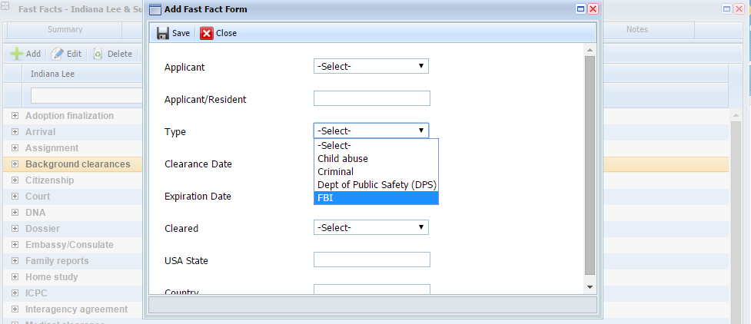

|  |  |  |  |
| --- | --- | --- | --- |
| **ColumnName** | **Type** | **Length** |  |
| Id | int | 4 | |  | | --- | |  | | |
| LkpName | varchar | 250 |
| DisplayField | varchar | 250 |
| ValueField | varchar | 250 |
| Query | varchar | -1 |
| Parameter | varchar | 250 |

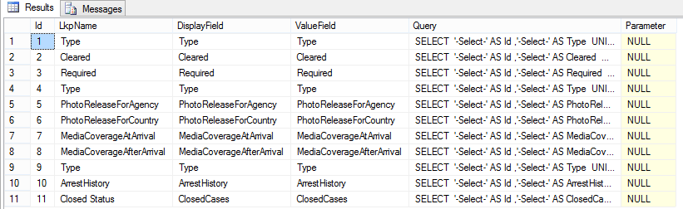

**FastFactsConfiguration:**

In this table we are using to configure the fast facts templates and corresponding fields.



|  |  |  |  |
| --- | --- | --- | --- |
| **ColumnName** | **Type** | **Length** |  |
| ID | int | 4 | |  | | --- | |  | | |
| FieldId | int | 4 |
| FieldName | varchar | 100 |
| Caption | varchar | 100 |
| FieldType | int | 4 |
| Seq | int | 4 |
| DataField | varchar | 100 |
| LookUpId | int | 4 |
| ItemId | int | 4 |

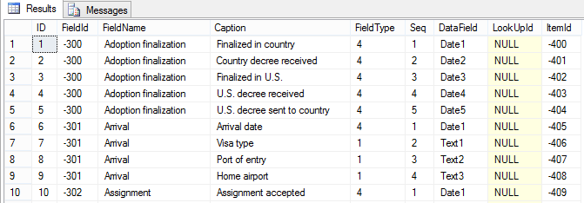

**FastFactData:**

It is used to store all fast facts data. Here we are using Date1 to date 10 fields for storing dates and Text1 to text 10 for String fields. Each fields are mapped by using fast facts configuration table.

|  |  |  |  |
| --- | --- | --- | --- |
| **ColumnName** | **Type** | **Length** |  |
| ID | int | 4 | |  | | --- | |  | | |
| User_ID | int | 4 |
| Connid | int | 4 |
| Connectionid | int | 4 |
| Rel_CustomTemplateId | int | 4 |
| Rel_CustomDataId | int | 4 |
| Date1 | datetime | 8 |
| Date2 | datetime | 8 |
| Date3 | datetime | 8 |
| Date4 | datetime | 8 |
| Date5 | datetime | 8 |
| Date6 | datetime | 8 |
| Date7 | datetime | 8 |
| Date8 | datetime | 8 |
| Date9 | datetime | 8 |
| Date10 | datetime | 8 |
| Text1 | varchar | -1 |
| Text2 | varchar | -1 |
| Text3 | varchar | -1 |
| Text4 | varchar | -1 |
| Text5 | varchar | -1 |
| Text6 | varchar | -1 |
| Text7 | varchar | -1 |
| Text8 | varchar | -1 |
| Text9 | varchar | -1 |
| Text10 | varchar | -1 |
| Created BY | int | 4 |
| CreatedDate | datetime | 8 |
| ModifiedBy | int | 4 |
| ModiFiedDate | datetime | 8 |

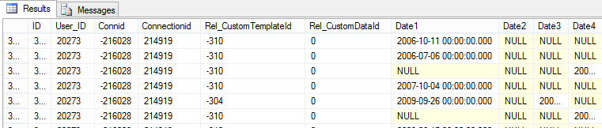

**USP_SaveFastFactsData:**

This Procedure is used to save all fast facts dates and text data into fastfactdata table. When we are inserting or update values it will update or insert values in the **Rel_CustomData** table and vice versa. We are using a trigger named **UpdateRelcustomdate** for updating value in fastfactdata table. Below script for **USP_SaveFastFactsData** and **UpdateRelcustomdate.**



**USP_GetFastFactData:**

This procedure is used to display fast fact data from the fastfactdata based on the contact.

|  |  |  |  |
| --- | --- | --- | --- |
| **Parameter name** | **Type** | **Length** |  |
| @Rel_CustomTemplateId | int | 4 |  |
| @User_id | int | 4 |
| @connid | int | 4 |
| @connectionid | int | 4 |
| @Id | int | 4 |